**Project Report: AI-Powered Insurance Policy Information Chatbot**

Made by Abhijith Prakash

**1. Introduction**

Insurance customers often struggle to understand complex policy details, coverage options, and claim procedures. Traditional customer support channels (call centers, emails) are slow and inefficient. PolicyBot addresses this by providing instant, accurate, and conversational responses to insurance related queries using Generative AI.

**Objective**

Develop an AI chatbot that:

* Answers policy-related questions in natural language
* Retrieves information from a structured knowledge base
* Escalates complex queries to human agents
* Provides a user-friendly interface

**2. Methodology**

**2.1 Approach Selection**

|  |  |
| --- | --- |
| Approach | Why Selected |
| Google Gemini 1.5 Flash LLM | Better than GPT-4 for cost, speed, and accuracy in insurance domain, building an LLM model from scratch can take time, also when hosting online we get limited CPU for free which can make it impossible to run it online. |
| FastAPI Backend | Lightweight, async-ready, and scalable for real-time chatbot responses. |

**2.2 System Architecture**

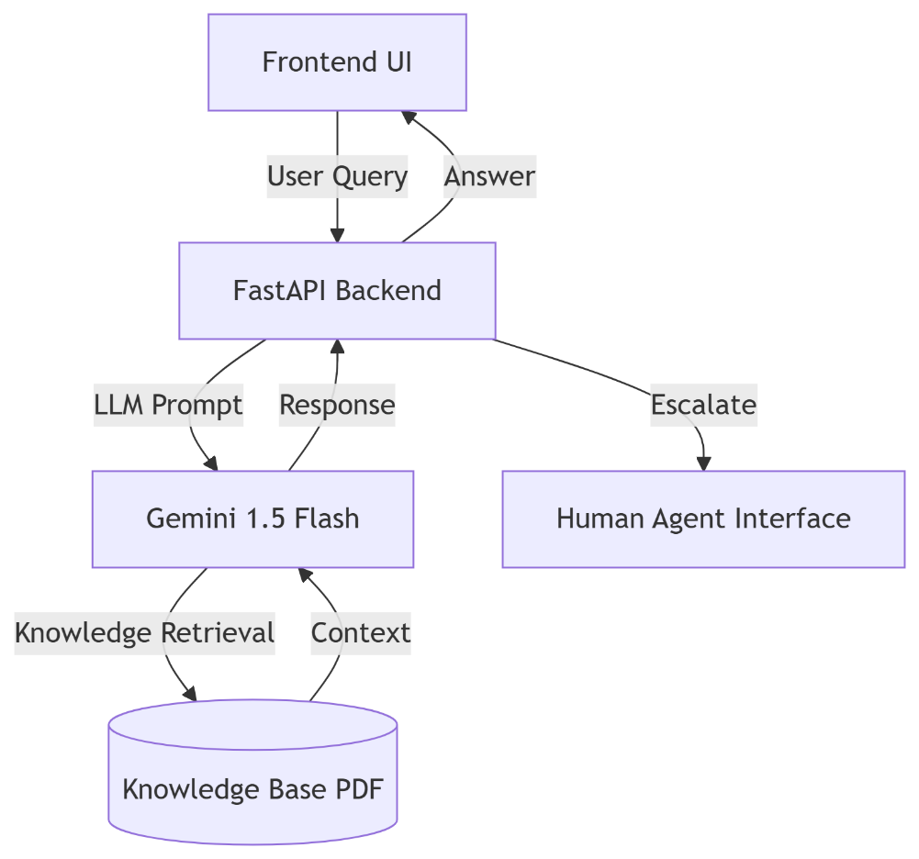

**2.3 Implementation Steps**

1. Knowledge Base Preparation

* Created a dummy dataset covering health, auto, home, and life insurance
* Extracted text from PDF using PyPDF2 and formatted for LLM prompts

1. Backend Development

* Built a REST API with FastAPI to handle user queries
* Integrated Gemini 1.5 Flash for NLP with context-aware prompts

1. Frontend Design

* Developed a responsive chat interface with:
* Quick-action buttons (e.g., "Explain claims process")
* Typing indicators and smooth animations
* Human agent escalation feature

1. Conversation Management

* Maintained chat history for context
* Detected intent to transfer to human support

**3. Results**

* Accurate Responses
* Handled FAQs (premiums, coverage, claims) effectively
* Seamless Human Escalation:
* Detected phrases like "I want to talk to an agent"
* Simulated smooth transfer to human representative

**User Experience:**

* Quick-action buttons reduced typing.

**4. Why This Approach?**

1. Gemini Over Other LLMs

* Cheaper (Free) than GPT-4 for similar accuracy
* Optimized for real-time chat
* Handled insurance terminology well
* Lightweight as it is an API rather a fully-fledged LLM model.

1. FastAPI Backend

* Handled multiple users efficiently
* Simplified frontend-backend integration

1. PDF Knowledge Base

* Avoided hallucinations by grounding answers in the PDF
* Modify PDF without retraining models

**5. Challenges & Solutions**

|  |  |
| --- | --- |
| Challenge | Solution |
| LLM sometimes gave generic answers | Improved prompt engineering with strict guidelines |
| Slow PDF text extraction | Pre-processed and cached knowledge base |
| Mobile responsiveness | CSS Flexbox/Grid media queries |

**6. Conclusion & Future Work**

PolicyBot successfully demonstrated how AI can improve insurance customer support.

* Made it faster for customers to know about the insurance’s details. And guided them automatically. Therefore, increasing the engagement in the website.
* Lowered customer support costs.
* Improved accessibility via 24/7 chat

**Next Steps**

* Add multilingual support
* Integrate text recognition (OCR) for image uploading.
* Website Implementation as a chatbot.

**Screenshots:**

**Frontend:**  
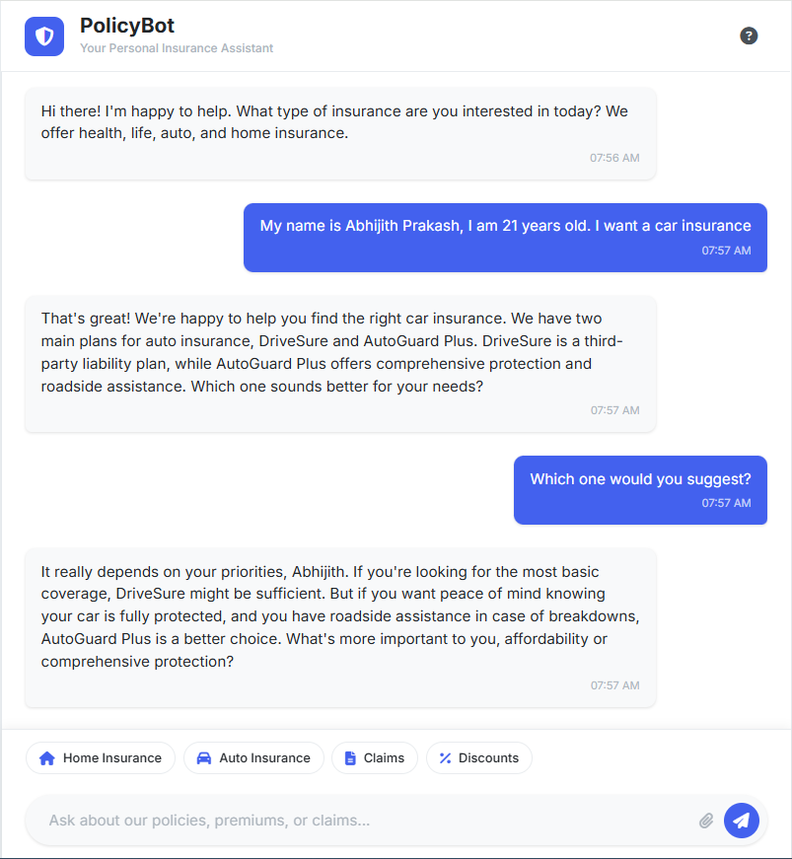

**Backend:**  
